**Compass MED D - Disenrollment Transfer Procedures**

General Information

Disenrollment Reasons Transferred to Premium Billing Specialized Team

Disenrollment Reasons Transferred to Specialized Member Services Team (SMST)

Disenrollment Reasons Handled by the CCR

Related Documents

**Description:** The document assists the MED D Customer Service Representative with identifying the reason for disenrollment and where to transfer the call.

**Target Audience:** SilverScript

| General Information |
| --- |

When researching the reason why a MED D Beneficiary has been disenrolled, the CCR should refer to the **Disenrollment Reason** field located on the **Medicare D Landing Page** within the **Enrollment Details** section.

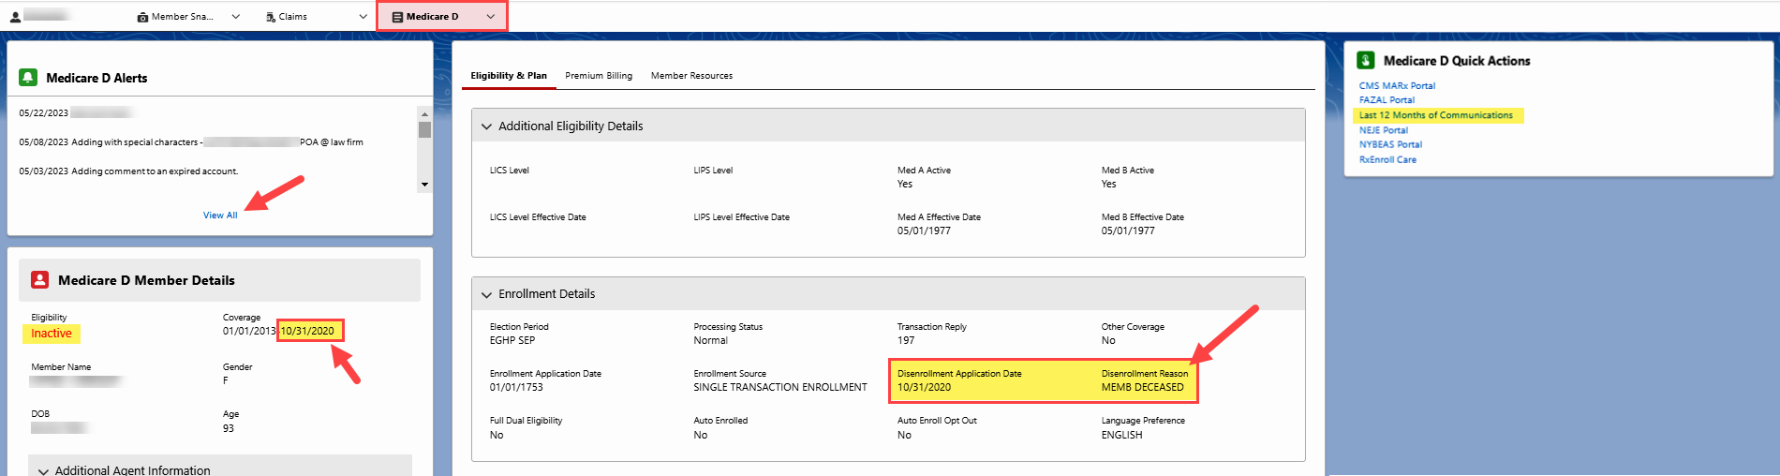

**Note:** The CCR should also reference **ALL** disenrollment letters in the **Last 12 months of Communications** hyperlink(located within the **Medicare D Quick Actions** panel), **ALL** previous call notes in the Member Snapshot Landing Page - **Alerts**,and **Medicare D** Landing Page– **Medicare D Alerts** for processing notes.

Top of the Document

|  |
| --- |
| Disenrollment Reasons Transferred to Premium Billing Specialized Team |

The below Disenrollment Reasons MUST WARM Transferred to the Med D Premium Billing Specialized Team at 1-866-824-4055.

* INVOLUNT DISENROLL NO PAY PREM
* NON NEJE INV TERM

Refer to [Aetna MED D - SilverScript Only - Premium Billing Warm Transfer Job Aid](../../AppData/Local/Microsoft/Windows/INetCache/Content.Outlook/40ZZSJWS/TSRC-PROD-012619).

Top of the Document

|  |
| --- |
| Disenrollment Reasons Transferred to Specialized Member Services Team (SMST) |

The below Disenrollment Reasons MUST WARM Transferred to the Specialized Member Services Team (SMST). For HealthPlan/EGWP transfer to 1-844-234-8264; for SilverScript transfer to 1-833-458-0858.

* DISENROLL - NEW MMP
* DISENROL - NEW MCO
* INCARCERATED
* UNLAWFULLY PRESENT
* LOSS PART D ELIGIBILITY
* MEMB DECEASED
  + Beneficiary is not deceased (Incorrect Date of Death Reported)
* NOT ENROLLED
* OUT OF AREA DISENROLLMENT

Refer to [MED D - Guide to Transferring a Call](../AppData/Local/Microsoft/Windows/INetCache/Content.Outlook/40ZZSJWS/TSRC-PROD-029866).

Top of the Document

|  |
| --- |
| Disenrollment Reasons Handled by the CCR |

|  |  |
| --- | --- |
| **Disenrollment Reason** | **Process** |
| **UNLAWFULLY PRESENT** | [Compass MED D - SilverScript and Blue MedicareRx (NEJE) - Resolving Eligibility Issues for Incarcerated or Not Lawfully Present Beneficiaries](https://thesource.cvshealth.com/nuxeo/thesource/#!/view?docid=8824428c-b769-4917-83bf-19549ec6f873) |
| **INCARCERATION** | [Compass MED D - SilverScript and Blue MedicareRx (NEJE) - Resolving Eligibility Issues for Incarcerated or Not Lawfully Present Beneficiaries](https://thesource.cvshealth.com/nuxeo/thesource/#!/view?docid=8824428c-b769-4917-83bf-19549ec6f873) |
| **INVOL EGWP DSNRLL - ADV NTC** | Review the applicable CIF for additional information for appropriate team that would handle the disenrollment. |
| **IRMAA DISENROLLMENT** | [Compass MED D SilverScript - Process for Good Cause Determinations - For Non-payment of Part D-IRMAA](https://thesource.cvshealth.com/nuxeo/thesource/#!/view?docid=be7314b7-c0f7-4f6b-ada6-7e9267b1852b)  [MED D Blue MedicareRx (NEJE) - Process for Good Cause Determination for Non-payment of Part D-IRMAA](../CMS-PRD1-114384) |
| **MEMB DECEASED** | [Compass MED D - Deceased Beneficiary](https://thesource.cvshealth.com/nuxeo/thesource/#!/view?docid=03532634-0441-4503-8b66-d19f9eec0c32)  **Note:** Do **NOT** send a Support Task to notify Enrollment Operations of the beneficiary’s death. |

Top of the Document

|  |
| --- |
| Related Documents |

* Refer to the “Grievance Standard Verbiage (for use in Discussion with Beneficiary)” section in the appropriate work instruction linked to from [Compass MED D - Grievances Index](https://thesource.cvshealth.com/nuxeo/thesource/#!/view?docid=70034f51-77df-49a4-ae97-7d3d63b216b3).
* [Aetna MED D - SilverScript Only - Premium Billing Warm Transfer Job Aid](../TSRC-PROD-012619)
* [MED D - Guide to Transferring a Call](../../AppData/Local/Microsoft/Windows/INetCache/Content.Outlook/40ZZSJWS/TSRC-PROD-029866)

**Parent SOP:** CALL-0048: [Medicare Part D - Customer Care Call Center Requirements, CVS Caremark Part D Services, L.L.C.](https://policy.corp.cvscaremark.com/pnp/faces/DocRenderer?documentId=CALL-0048)

**Abbreviations/Definitions:** [Abbreviations / Definitions](../../AppData/Local/Microsoft/Windows/INetCache/Content.Outlook/40ZZSJWS/CMS-2-017428)

Top of the Document

Not To Be Reproduced Or Disclosed to Others Without Prior Written Approval

**ELECTRONIC DATA = OFFICIAL VERSION / PAPER COPY = INFORMATIONAL ONLY**